COLOR THEORY WORKSHEET
Color theory is primarily about how colors are mixed, and what we perceive visually when specific colors interact with each other.
Color is defined by three properties. These properties are:
- Hue – is the name of the color.
- Value – is the degree of lightness or darkness of a color.
- Intensity (or Chroma ) – is the degree of saturation or desaturation of a color.

Creating a Color Wheel

A primary color is a color that cannot be created by mixing .

A secondary color is a color that is created by mixing two primary colors .

A tertiary or inrtermediate color is a color that is created by mixing a primary and a secondary .

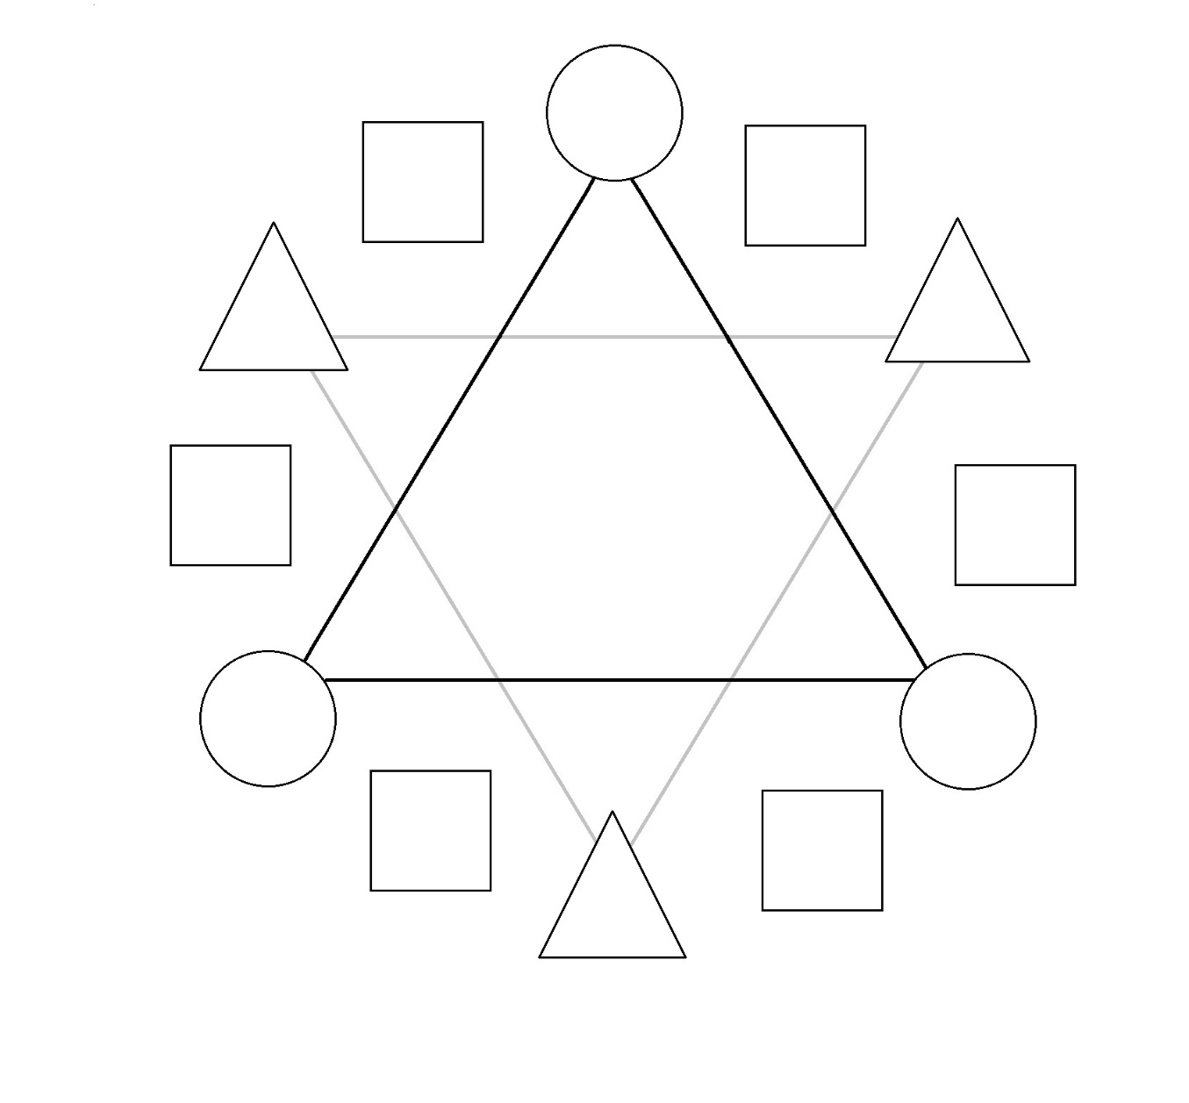
Secondary
Primary
Color Groupings

  Monochromatic | Complimentary | Split-Complimentary
Analogous | Triadic | Tetradic

Atmospheric (or Arial) Perspective:
The illusion of depth created by neutralizing or desaturating hues and blurring edges of objects to have them appear further away.

Color Temperatures:
The grouping of analogous colors into warms and cools.

Tints: hues created by adding white .
Shades: hues created by adding black .

Tone: hues created by adding grey .

Thoughts on Art: Michael Wille
Please answer the following questions in complete sentences, and turn this worksheet in before the end of this class period.

Artist
How is Michael Wille’s art created?

Artwork
Michael Wille’s color choices and non-representational style of painting is meant to elicit conversation about the artwork or works in a series purely on the basis of his color choices and painting techniques. Please describe one of the examples of his work presented in class using descriptive language as if you were describing it to someone over the phone. (No, you cannot just send them a pic.)

Audience
Who is the intended audience for this artists work?

World
After viewing Wille’s work, what would you say influences him around the world or from culture?

