Read Preston Singletary’s artist’s statement below. Then answer the questions that follow.
Preston Singletary  Artist’s Statement | When I began working with glass in 1982, I had no idea that I'd be so connected to the material in the way that I am. It was only when I began to experiment with using designs from my Tlingit cultural heritage that my work began to take on a new purpose and direction.  Over time, my skill with the material of glass and traditional form line design has strengthened and evolved, allowing me to explore more fully my own relationship to both my culture and chosen medium. This evolution, and subsequent commercial success, has positioned me as an influence on contemporary indigenous art.  Through teaching and collaborating in glass with other Native, Maori, Hawaiian, and Australian Aboriginal artists, I've come to see that glass brings another dimension to indigenous art. The artistic perspective of indigenous people reflects a unique and vital visual language which has connections to the ancient codes and symbols of the land, and this interaction has informed and inspired my own work.  My work with glass transforms the notion that Native artists are only best when traditional materials are used. It has helped advocate on the behalf of all indigenous people—affirming that we are still here—that that we are declaring who we are through our art in connection to our culture.  My work continues to evolve and connect my personal cultural perspective to current modern art movements, and I have received much attention for striving to keep the work fresh and relevant. I have been honored that my success has inspired other artists from underrepresented indigenous cultures to use glass and other non-traditional materials in their work, and hope that I can continue to encourage more innovation in this area as my career progresses.

Artist’s Statement Questions
1) Name two major influences on Singletary’s work

2) How has Singletary used his success as an artist? What has he done with it?

3) Why does Singletary feel his medium is important to indigenous art?

Read the review by Haidy Geismar of Echoes, Fire, and Shadow from July 20, 2011 in the Material World blog at:
http://www.materialworldblog.com/2011/07/preston-singletary-echoes-fire-and-shadows/

Write a paragraph that summarizes the review of Singletary’s exhibition that explains the significance of Singletary’s work: (Claim, explanation, evidence, tieback)
_______________________________________________________________________________________________________________________________________________________________________________________________________________________________________________________________________________________________________________________________________________________________________________________________________________________________________________________________________________________________________________________________________________________________________________________________________________________________________________________________________________________________________________________________________________________________________________________________________________________________________________________________________________________________________________________________________________________________________________________________________________________________________________________________________________________________________________________________________________________________________________________________________________________________________________________________________________________________________________________________________________________________________________________________________________________________________________________________________________________________________________________________________________________________________________________________________________________________________________________________________________

Define five (5) words you were unfamiliar with before reading this review.
1.
2.
3.
4.
5.

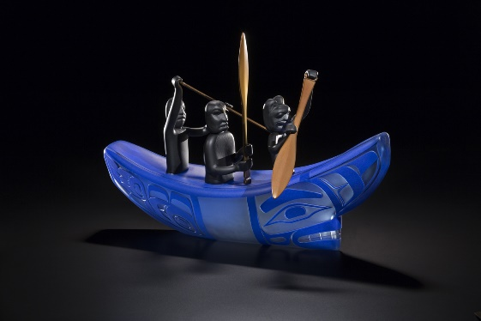 | 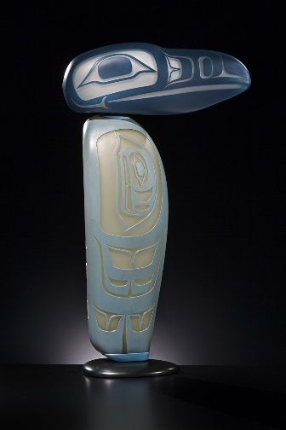 | 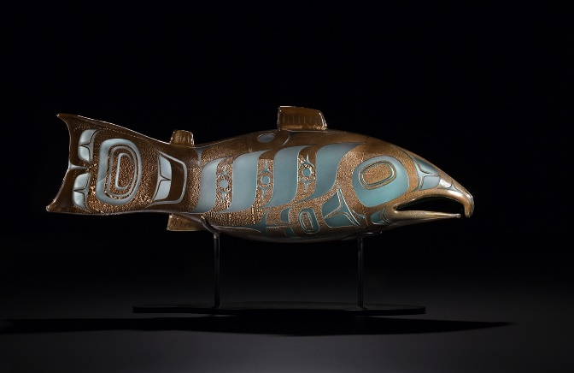

List 5 adjectives that you would use to describe the images of Singletary’s work shown above:
__________________________________________________________________________________________________________________________________________________________________________

Write a paragraph describing one of the artworks. Be sure to use the adjectives you listed.
______________________________________________________________________________________________________________________________________________________________________________________________________________________________________________________________________________________________________________________________________________________________________________________________________________________________________________________________________________________________________________________________

Consider the following questions using our art frames. Write your own review of Singletary’s work below. Be sure to make a claim, explain why you made it, support it with evidence, and conclude it with a tieback.
Subjective: Why use glass rather than another medium?
Cultural: How does Singletary’s Tlingit heritage influence his art practice?
Structural: How does Singletary take advantage of the specific properties of glass?
Postmodern: What are the connections between the medium and the symbols?
______________________________________________________________________________________________________________________________________________________________________________________________________________________________________________________________________________________________________________________________________________________________________________________________________________________________________________________________________________________________________________________________

